Clinic Management System
Course: Information Systems — CMPn325
Under Supervision: Dr. Khaled Morsy
T.A Hadeer Kamal
Students:
ID | Name | Section
4240102 | John Emil Ramzy | TH-5
4240624 | Abdullah Mohamed Ahmed | TH-7
4240622 | Hazem Mohamed Abd Elhaseb | TH-7
4240223 | Belal Ahmed Mahmoud | TH-4
4240233 | Mohamed Abd ElNasser Galal | TH-5
4240225 | Youssef Omar Said | TH-7

Level: Level 2 Computer
Term: First Term: 2025–2026

Abstract
The Clinic Management System is a web-based application designed to streamline clinic operations through a centralized digital platform. The system provides secure access through user authentication, including sign up and login functionality, and offers separate dashboards for patients, doctors, and administrators.
Patients can request appointments with doctors and view their medical information. Doctors can manage their schedules, view their assigned patients, and add prescriptions. The administrator oversees the entire system, with the ability to add and manage doctors, patients, appointments, and prescriptions. The system enhances efficiency, reduces human error, and improves communication within the clinic.

4. System Development Life Cycle (SDLC)
4.1 Investigation
- The investigation phase identifies existing problems in clinic operations and determines the need for digital transformation.
- Identify issues in patient registration, appointment scheduling, and record management.
- Understand user needs for patients, doctors, and administrators.
- Determine system goals and required enhancements.
Feasibility Study
The feasibility study evaluates whether the system can be developed and implemented effectively.
a. Technical Feasibility
• The system can be developed using web technologies (frontend, backend, relational database).
• No special hardware is required beyond standard clinic computers and internet access.
b. Operational Feasibility
• Doctors, patients, and staff can easily use the system.
• The system reduces paperwork, minimizes errors, and improves workflow.
c. Economic Feasibility
• Development cost is justified by long-term savings in clinic operations.
• The system reduces manual labor and administrative overhead.
d. Schedule Feasibility
• The timeline for development is realistic and follows SDLC phases.
4.2 Analysis
- During this phase, system requirements are collected and analyzed to build a functional model of the clinic workflow.
Functional Requirements
Input Requirements
- Patient registration via sign up.
- Login credentials for authentication (JWT).
- Appointment requests submitted by patients.
- Prescription details entered by doctors.
- Doctor, patient, medicine, and appointment data entered by admin.
Output Requirements
- Patient dashboard displaying appointments and prescriptions.
- Doctor dashboard displaying scheduled appointments and patient details and prescriptions.
- Admin dashboard showing management tools.
Processing Requirements
- Authenticate users using JWT tokens.
- Authorize access based on user roles (patient, doctor, admin).
- Process patient appointment requests.
- Allow doctors to create prescriptions.
- Allow admin to add/edit doctors, patients, appointments, prescriptions
- Update dashboards dynamically.
Storage Requirements
- Relational database storage (Oracle DB)
Control Requirements
- Role-based access control using JWT.
- Audit logging for all data changes.
- Encryption of sensitive patient data.
- Input validation mechanisms to ensure data integrity.
Non-Functional Requirements:
• Security, data validation, and encryption
• High performance and system reliability
• User-friendly interface
4.3 Design
User Interface Design:
• Login / Signup pages
• Patient dashboard (appointments, prescriptions)
• Doctor dashboard (appointments, patients, prescriptions)
• Admin dashboard (full management tools)

Data Design (ERD):
Process Design
• Patient booking workflow
• Doctor prescription workflow
• Admin management workflow
• DFD Levels 0, 1, 2 for modeling data flow
DFD Level 0:
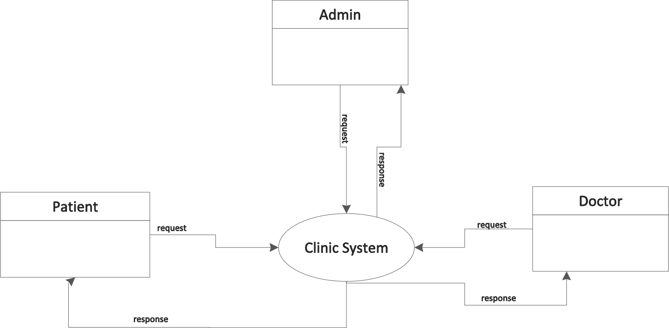

DFD Level 1:

DFD Level 2:
Sign up:

Login:

Add Patient:

Edit Patient:

Add Doctor:

Edit Doctor:

Add Appointment:

Edit Appointment:

Delete Appointment:

Add Prescription:

Edit Prescription:

Delete Prescription:

Process Design
- User signup and login using JWT authentication.
- Patient adds appointment.
- Admin adds appointments.
- Doctor adds prescriptions for patients.
- Admin manages doctors, patients, appointments, prescriptions
- Dashboards update dynamically based on user role.
4.4 Implementation
Tasks:
• Build frontend and backend modules
• Implement authentication and authorization
• Develop dashboards for all user roles
• Create database tables and relationships
• Integrate system modules using REST APIs
Technologies Used:
• Programming languages (React + Vite, Tailwind.css, Spring boot (Java))
• Relational database (Oracle)
• JWT for secure authentication
4.5 Maintenance
• Fixing bugs and errors
• Adding new features based on user feedback
• Enhancing performance and security
• Regular database backups

5. Outline of Systems Study
5.1 Objectives of the Study
• Identify issues in patient registration and appointment handling.
• Collect user requirements to build a digital information system.
• Implement secure role-based access for all users.

6. Detailed Results of Systems Study
6.1 Current System Description
The Clinic Management System provides separate dashboards for patients, doctors, and admins. Access is secured through authentication.
• Patient Dashboard: View appointments, prescriptions, and request new appointments.
• Doctor Dashboard: View appointments, patients, and add/edit prescriptions.
• Admin Dashboard: Manage doctors, patients, appointments, and prescriptions.

7. System Specifications
- User Interface: Dashboards for patients, doctors, and admins, login/sign up pages.
- Database: Relational tables with relationships, primary/foreign keys (Oracle DB).
- Software: Backend + frontend, REST APIs, JWT authentication.
- Hardware: Server for app and database.
- Personnel: Admins, doctors, staff, developers.
- Documentation: User manuals and system administrator guides.

8. Testing & Acceptance Criteria
- Users can sign up and log in securely with JWT.
- Patients can request appointments successfully.
- Doctors can add prescriptions for their patients.
- Admin can manage all users, appointments.
- Dashboards reflect real-time data updates.
- Data security and validation are enforced.

9. Output Screenshots:
Signup & Login
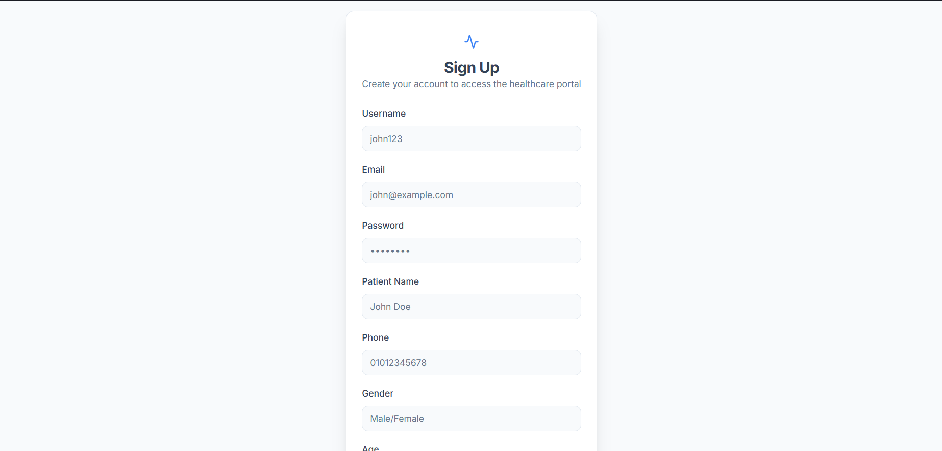

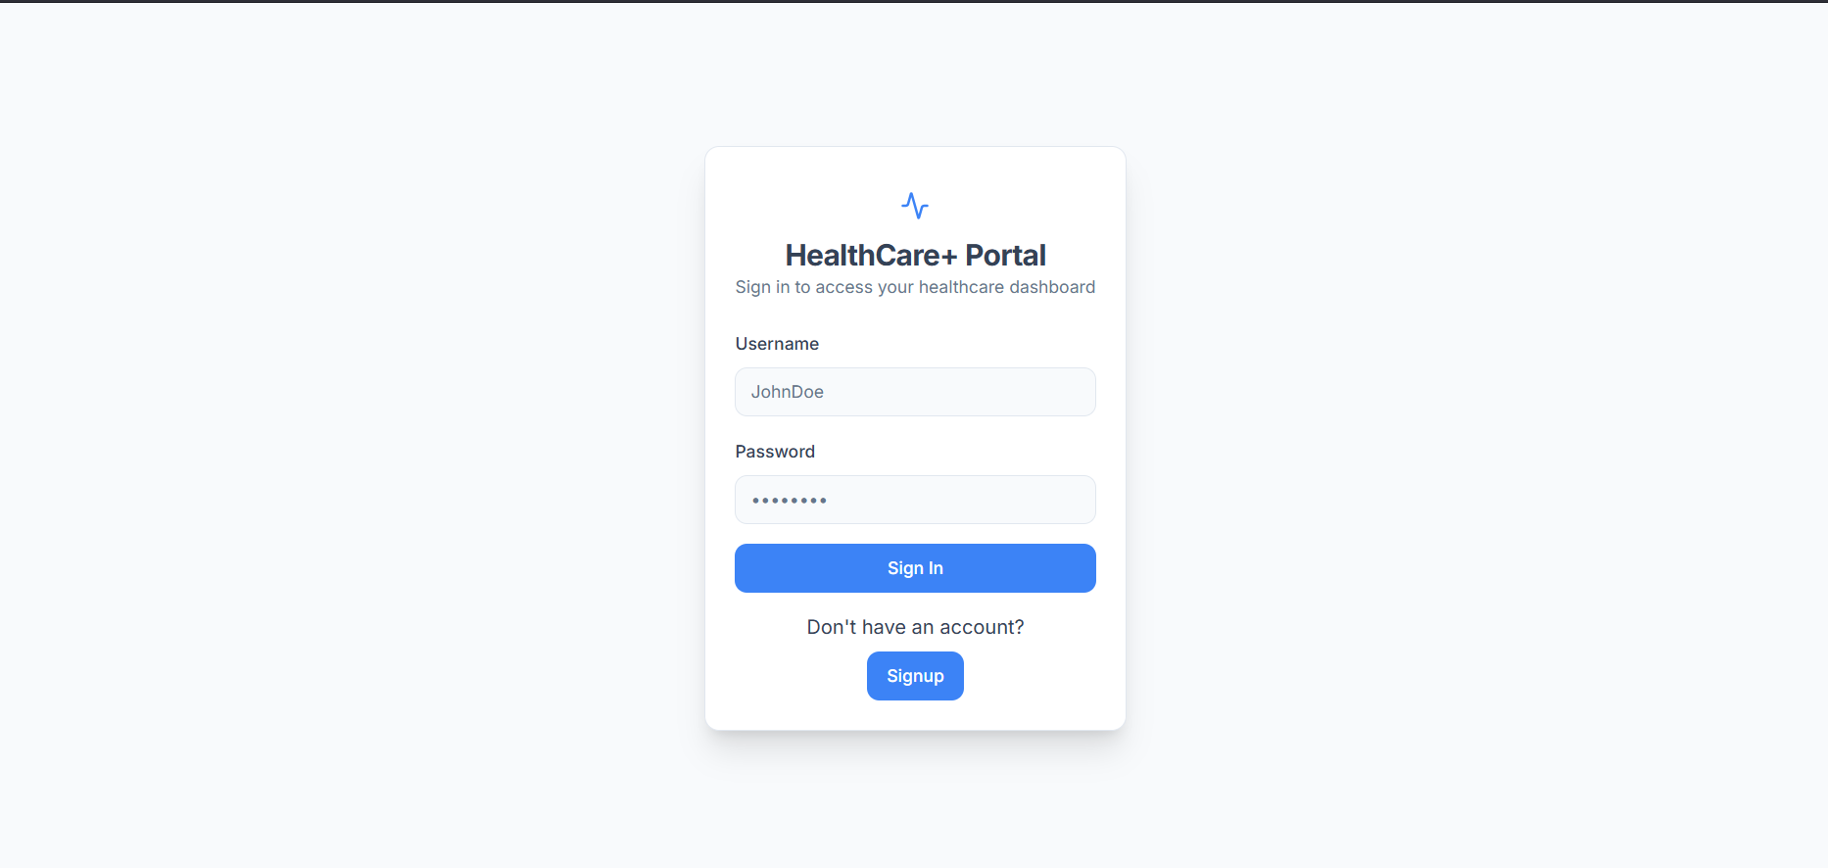

Patient Dashboard:

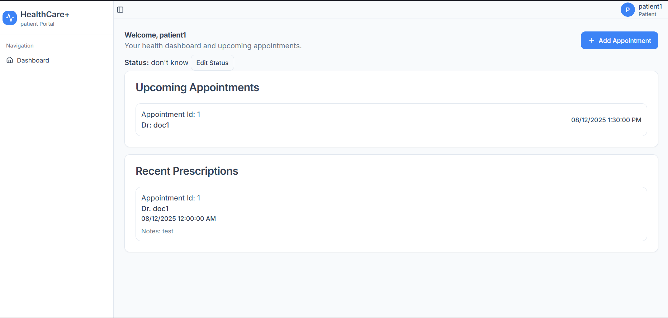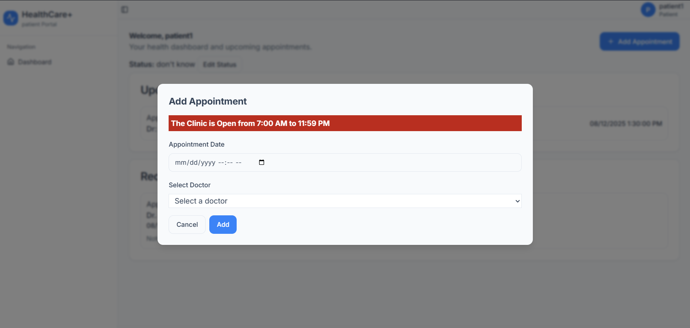

Doctor Dashboard:
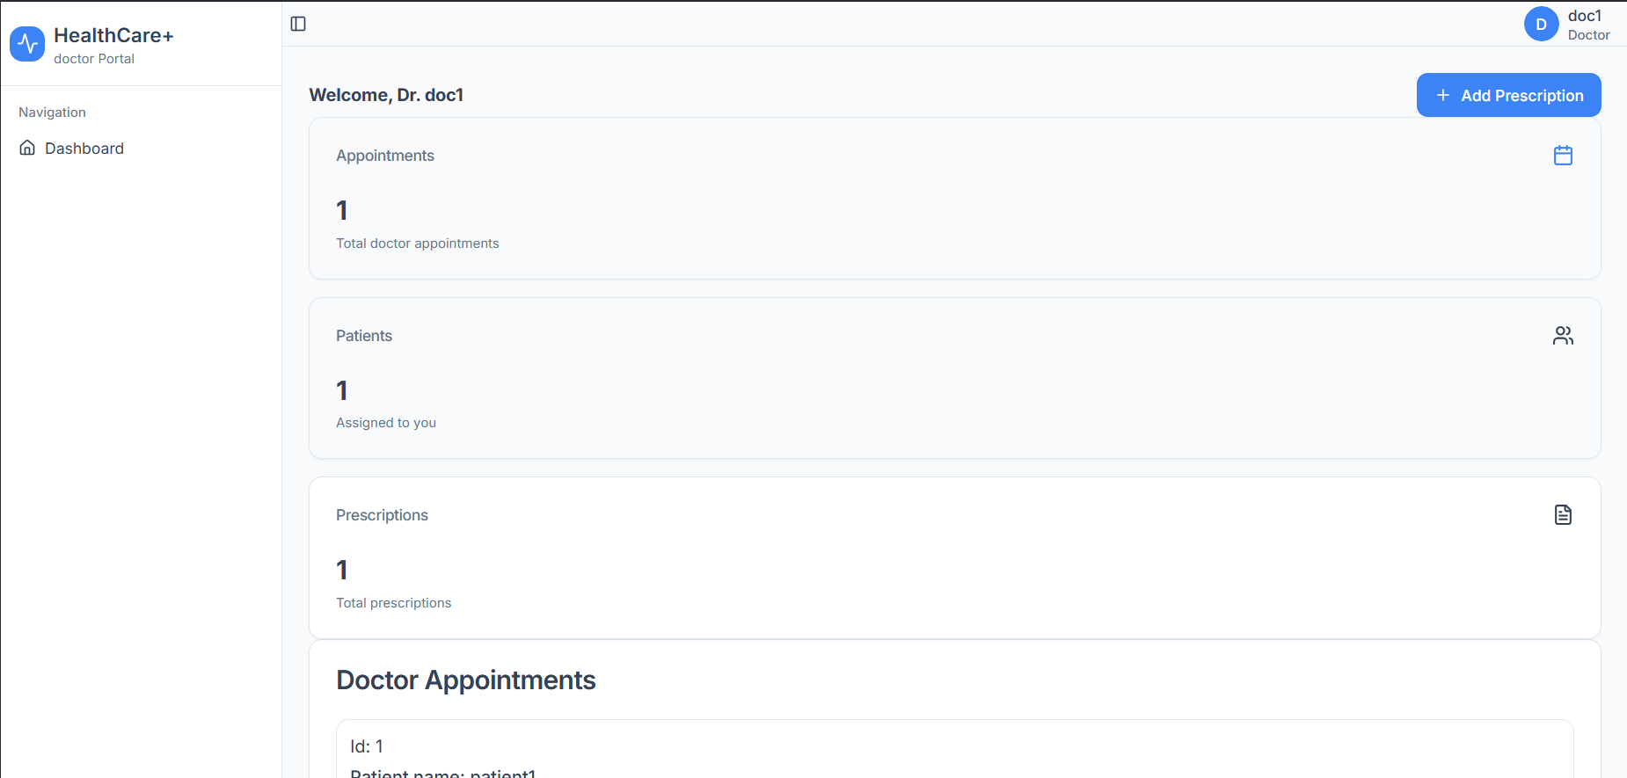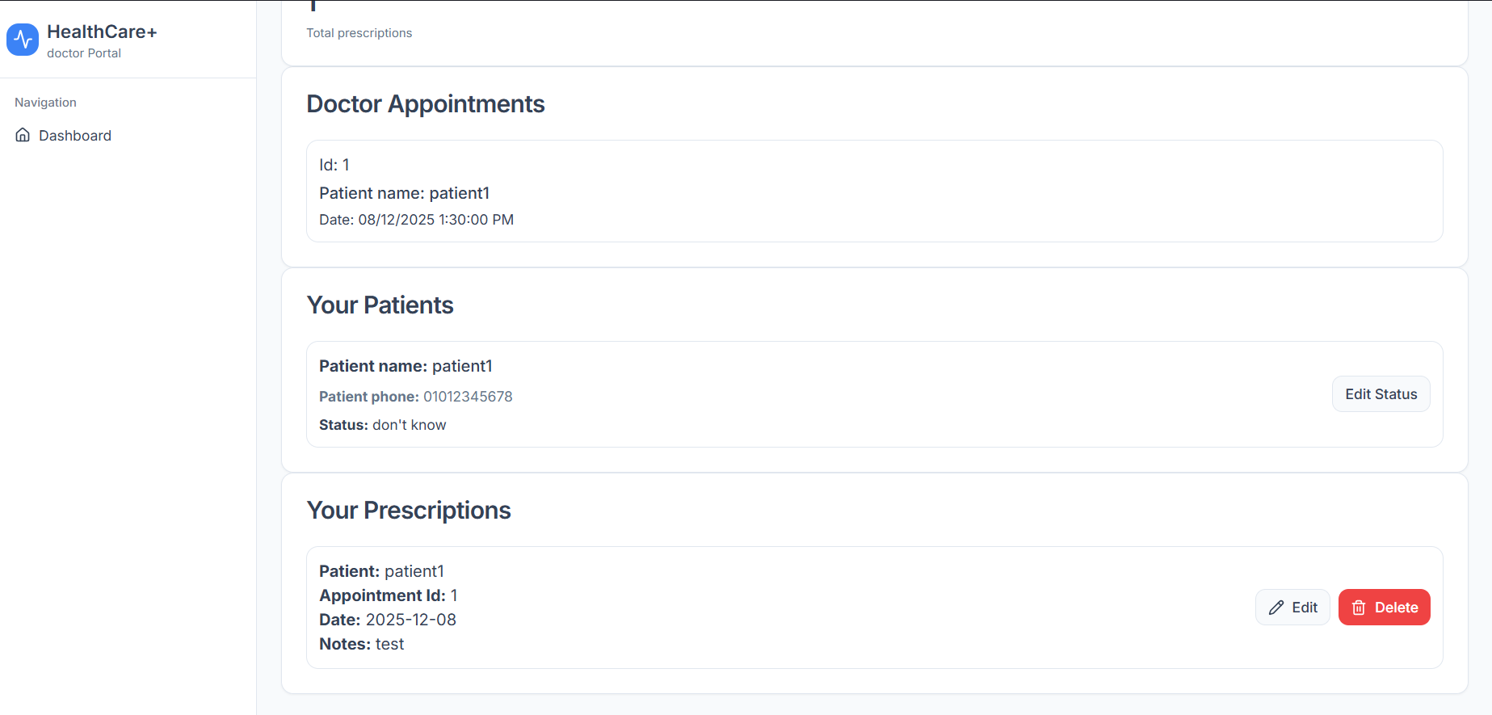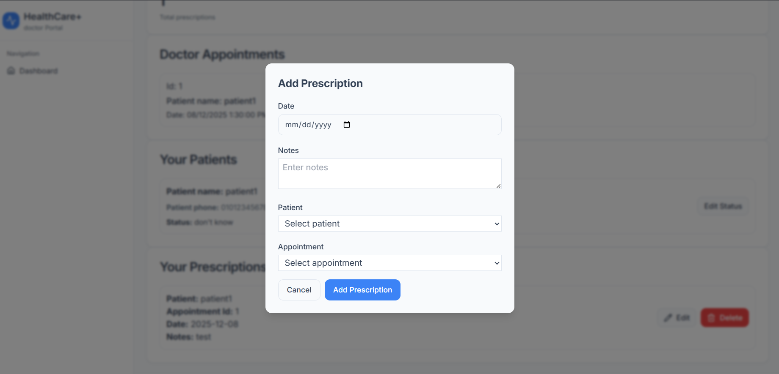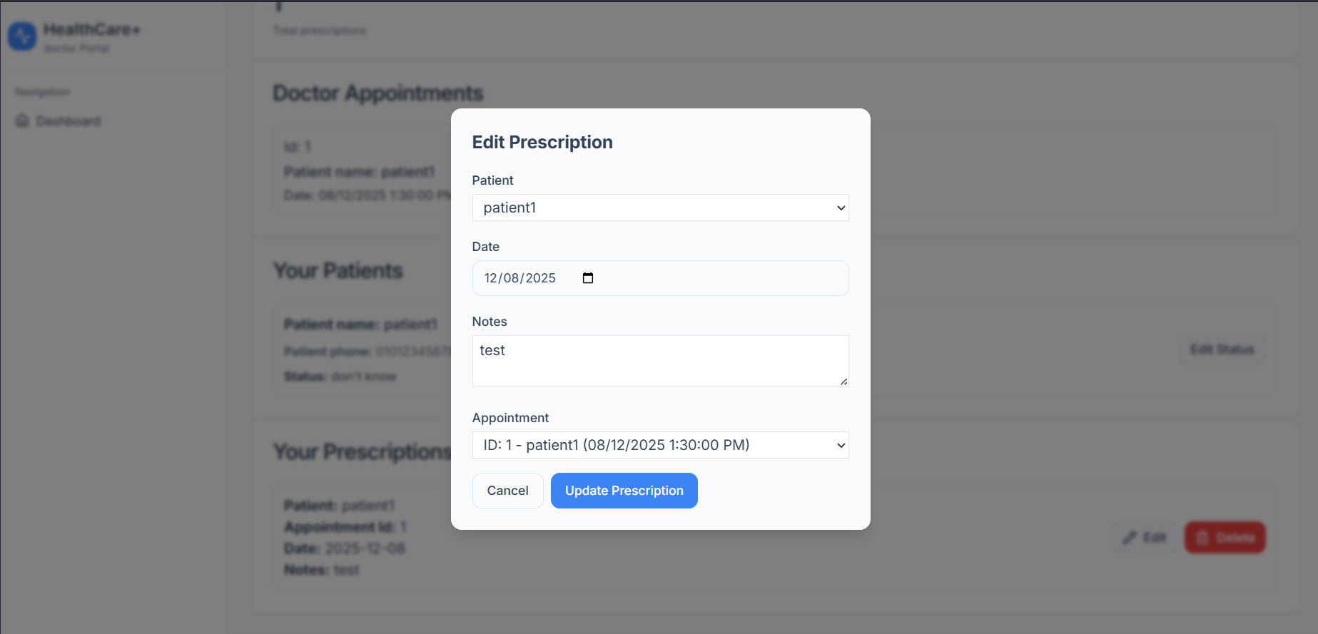

Admin Dashboard:

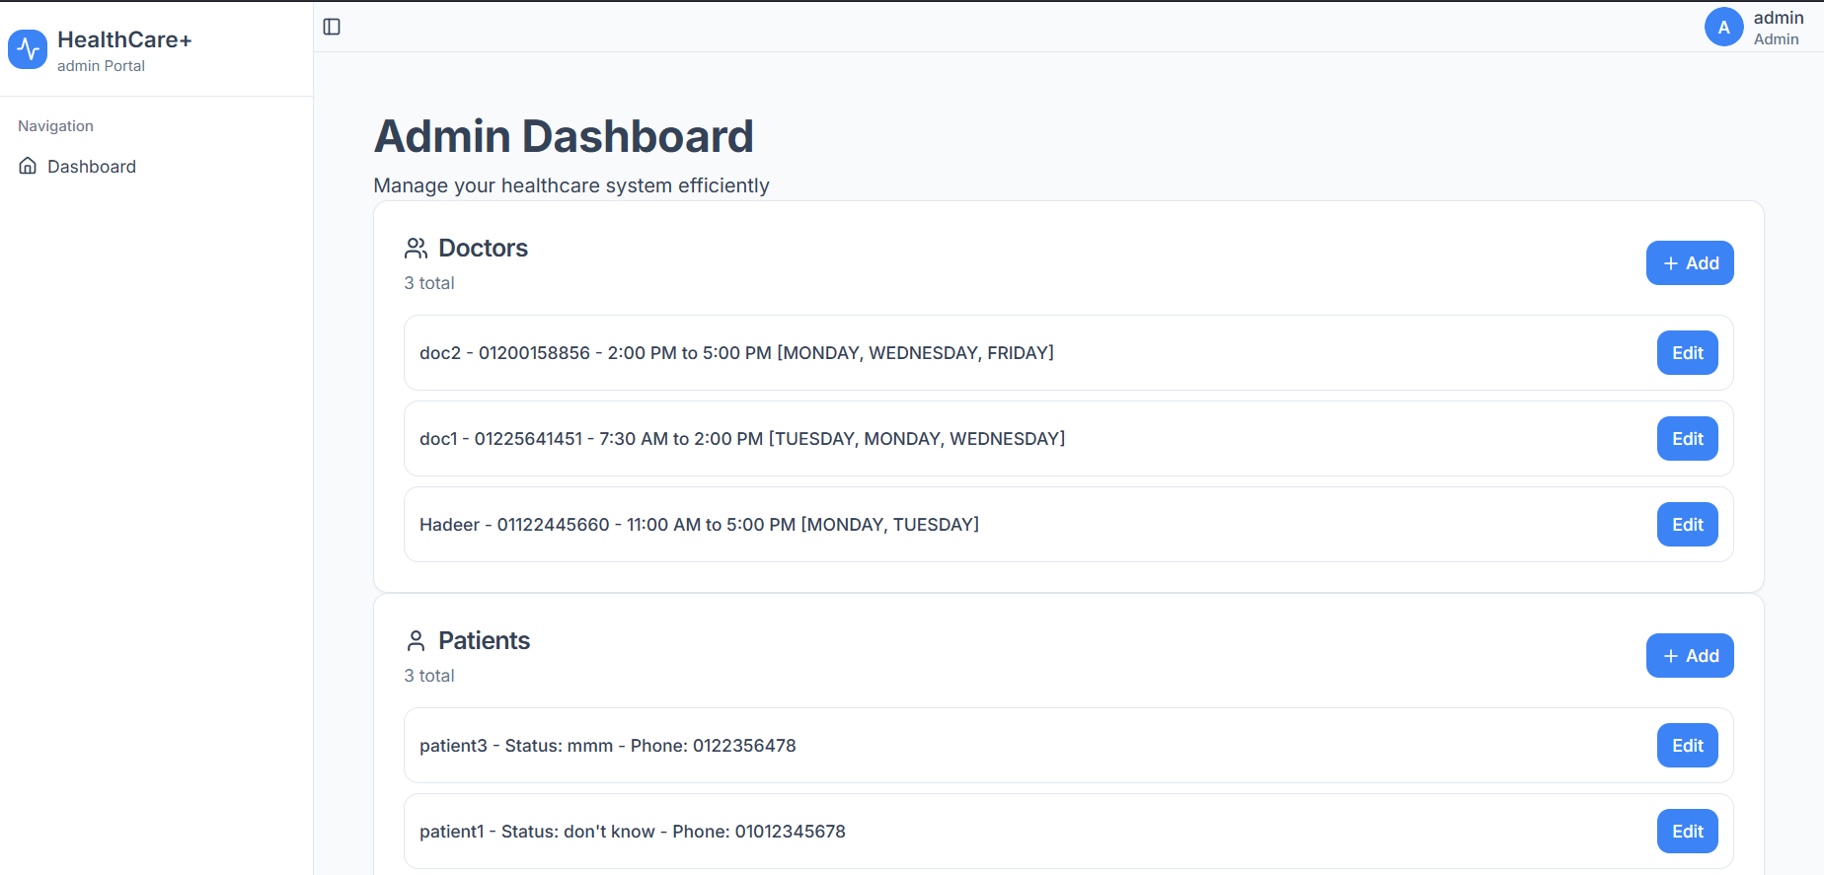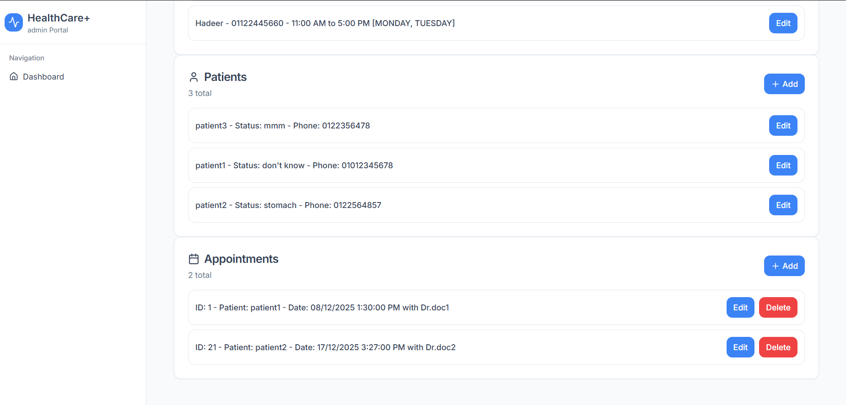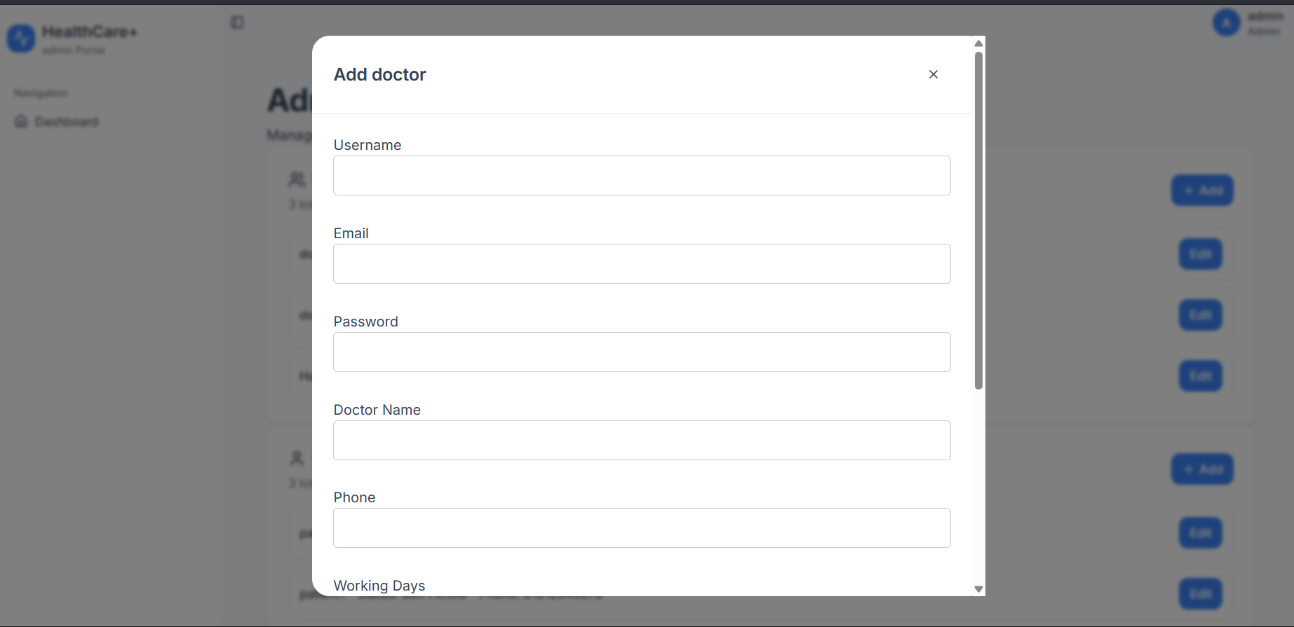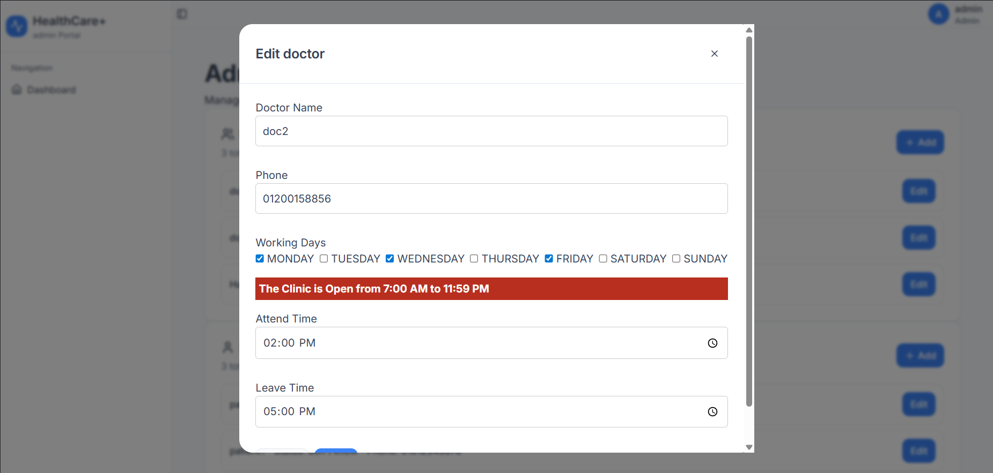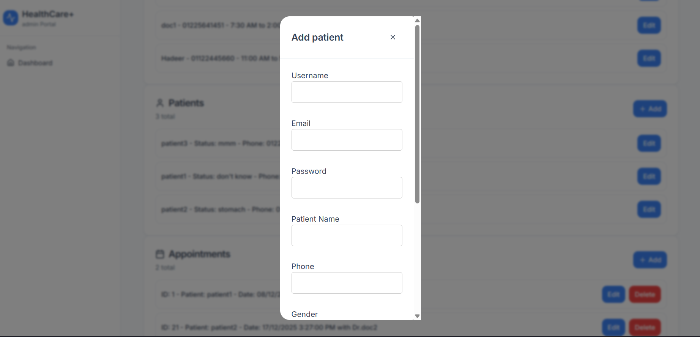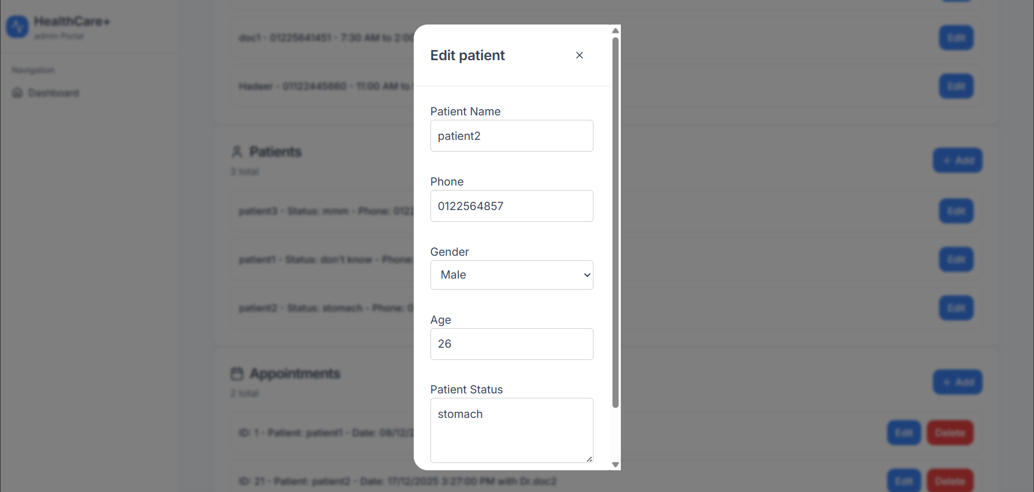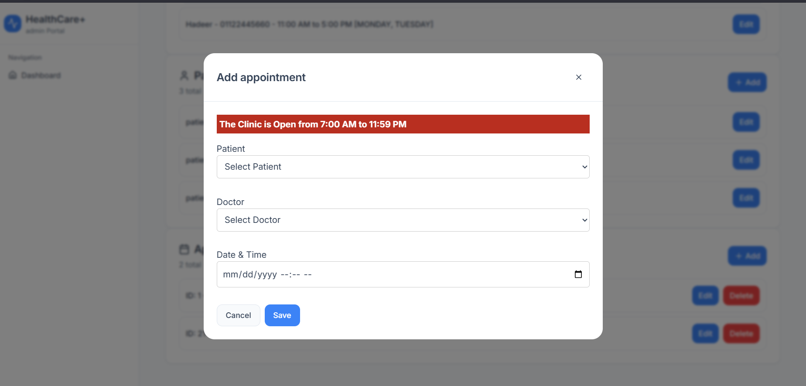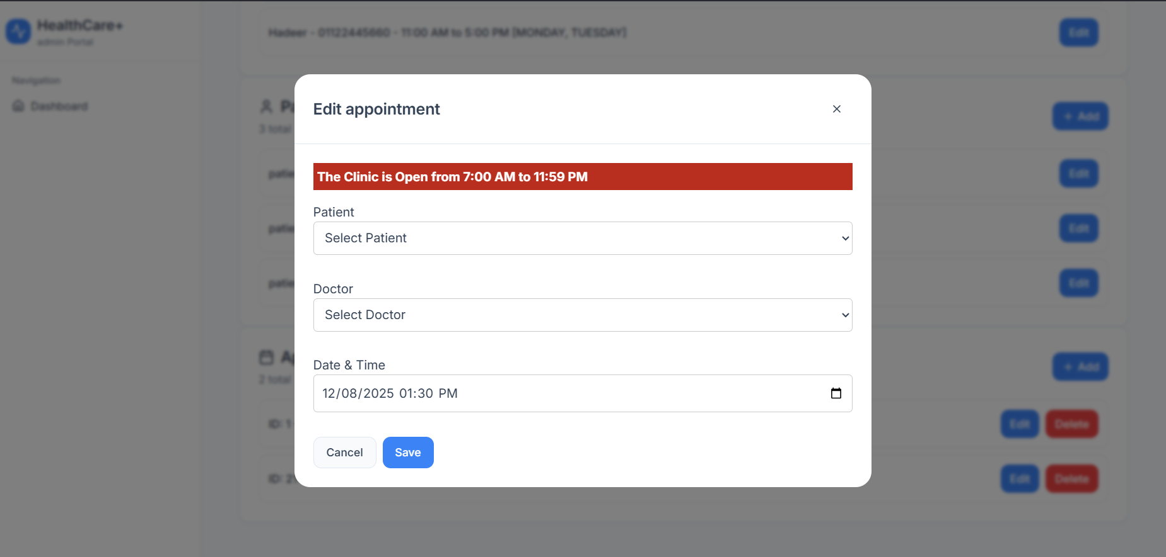

Schema:
